# VI. Release Package & User Guides

## 1. Deliverable Package

### 1.1 Source codes & documents

Table xx. Source codes & documents

|  |  |  |
| --- | --- | --- |
| **No** | **Items** | **Sub-Items** |
| **Code packages** | | |
| 1 | CFFE.CapstoneBE.zip |  |
| 2 | CFFE.CapstoneFE.zip |  |
| 3 | CFFE.Mobile.apk |  |
| **Databases** | | |
| 1 | Script | capstone.sql |

### 1.2 Known Issues, Limitations & Restrictions

## 2. Installation Guides

### 2.1 System Requirements

#### a. Back End Server requirements:

* Tested OS: RedHat 8 or above.
* Network: LAN, Internet access capability.
* Hardware configurations:

Table xx. Back End Server – Recommended hardware configuration

|  |  |  |  |
| --- | --- | --- | --- |
| **Type** | **Part/Component** | **Minimum** | **Recommended** |
| Computer | OS supported | RedHat | _ |
| Computer | Network | Internet | _ |
| Computer | RAM | 2GB | > 2GB |
| Computer | Cluster | 4 machines | 8 machines |
| Computer | Storage Space | 50GB | >50GB |
| Computer | Ports | Network | _ |

* Software requirements:
  + Java SE Development Kit 8: JDK 8u281
  + Apache Maven 3.6.3
  + MySQL 8.0
  + Python3.8.2

#### b. Web Server requirements

* Tested OS: RedHat 8 or MacOS.
* Network: LAN, Internet access capability.
* Hardware configurations:

Table xx. Back End Server – Recommended hardware configuration

|  |  |  |  |
| --- | --- | --- | --- |
| **Type** | **Part/Component** | **Minimum** | **Recommended** |
| Computer | OS supported | RedHat | _ |
| Computer | Network | Internet | _ |
| Computer | RAM | 2GB | > 2GB |
| Computer | Cluster | 4 machines | 8 machines |
| Computer | Storage Space | 50GB | >50GB |
| Computer | Ports | Network | _ |

* Software requirements:
  + Nodejs
  + Vue3

#### c. Mobile requirements

* Tested OS: RedHat 8 or MacOS.
* Network: LAN, Internet access capability.
* Hardware configurations:

Table xx. Back End Server – Recommended hardware configuration

|  |  |  |  |
| --- | --- | --- | --- |
| **Type** | **Part/Component** | **Minimum** | **Recommended** |
| Mobile | Android supported |  | _ |
| Mobile | Network | Internet | _ |

### 2.2 Environment setup requirements

* Operating system: RedHat 8.
* Java SE Runtime 8.
* Soft wares: MySQL 8.0.

### 2.3 Setup Files

* CFFE.CapstoneBE.zip: API for applications.
* CFFE.CapstoneWeb.zip: Web for Module Web.
* CFFE.CapstoneDetect.zip: Detect for Module Detect.
* CFFE.Mobile.apk:APK mobile for android*.*

### 2.4 Installation Instruction

#### a. Setup environment

##### 1. Setup and start a RedHat OS (RedHat 8 or above)**.**

**1.** Open browser and go to this URL: [Console Google Cloud](https://console.cloud.google.com/) then Login in with **Google account**



Figure xx. Login GCP form

**2.** Create a VM Instance with Red Hat Enterprise Linux 8:

1. Further information: Go to this URL [Create a Linux VM Instance | GCP](https://cloud.google.com/compute/docs/quickstart-linux)

2. Fill information and choose Boot Disk is Red Hat Enterprise Linux 8 image (1). Then, click “Create” Button (2).

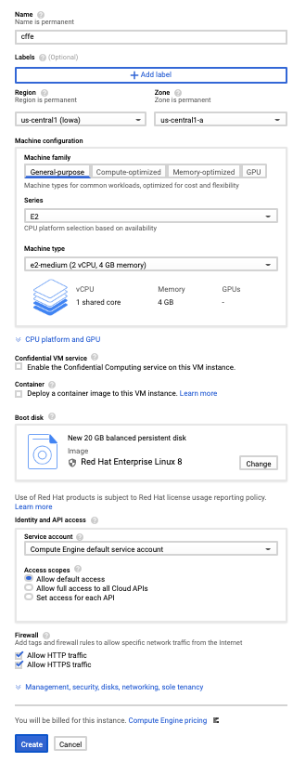

2

1

Figure xx. Choose configs VM

##### 2. Install Java Development Kit, Apache Maven, Python, NodeJS, MySQL

1. Connect Linux VM Instance. Further information: [Connecting to Linux VM Instance | GCP](https://cloud.google.com/compute/docs/instances/ssh#console)

2. Run an install script file:

1. Run as root user with this command: **sudo su –**



Figure xx. Run as root user

2. Prepare a “InstallModules.sh” file with this content:



Figure xx. “InstallModules.sh” file contents.

3.Start to install environment: **yes y | source ./InstallModules.sh**



Figure xx. Run the bash script file

4. Reload bash file system with this command: **source ~/.bashrc**



Figure xx. Reload the config bash file

5. Verification modules installed with commands:

* Check installed JDK (1): **java -version**
* Check installed Apache Maven (2): **mvn –version**
* Check installed Python (3): **python3.8 --version**
* Check installed NodeJS (4): **node –version**
* Check installed MySQL (5): **mysql –version**
* Check MySQL active status (6): **systemctl status mysqld.service**

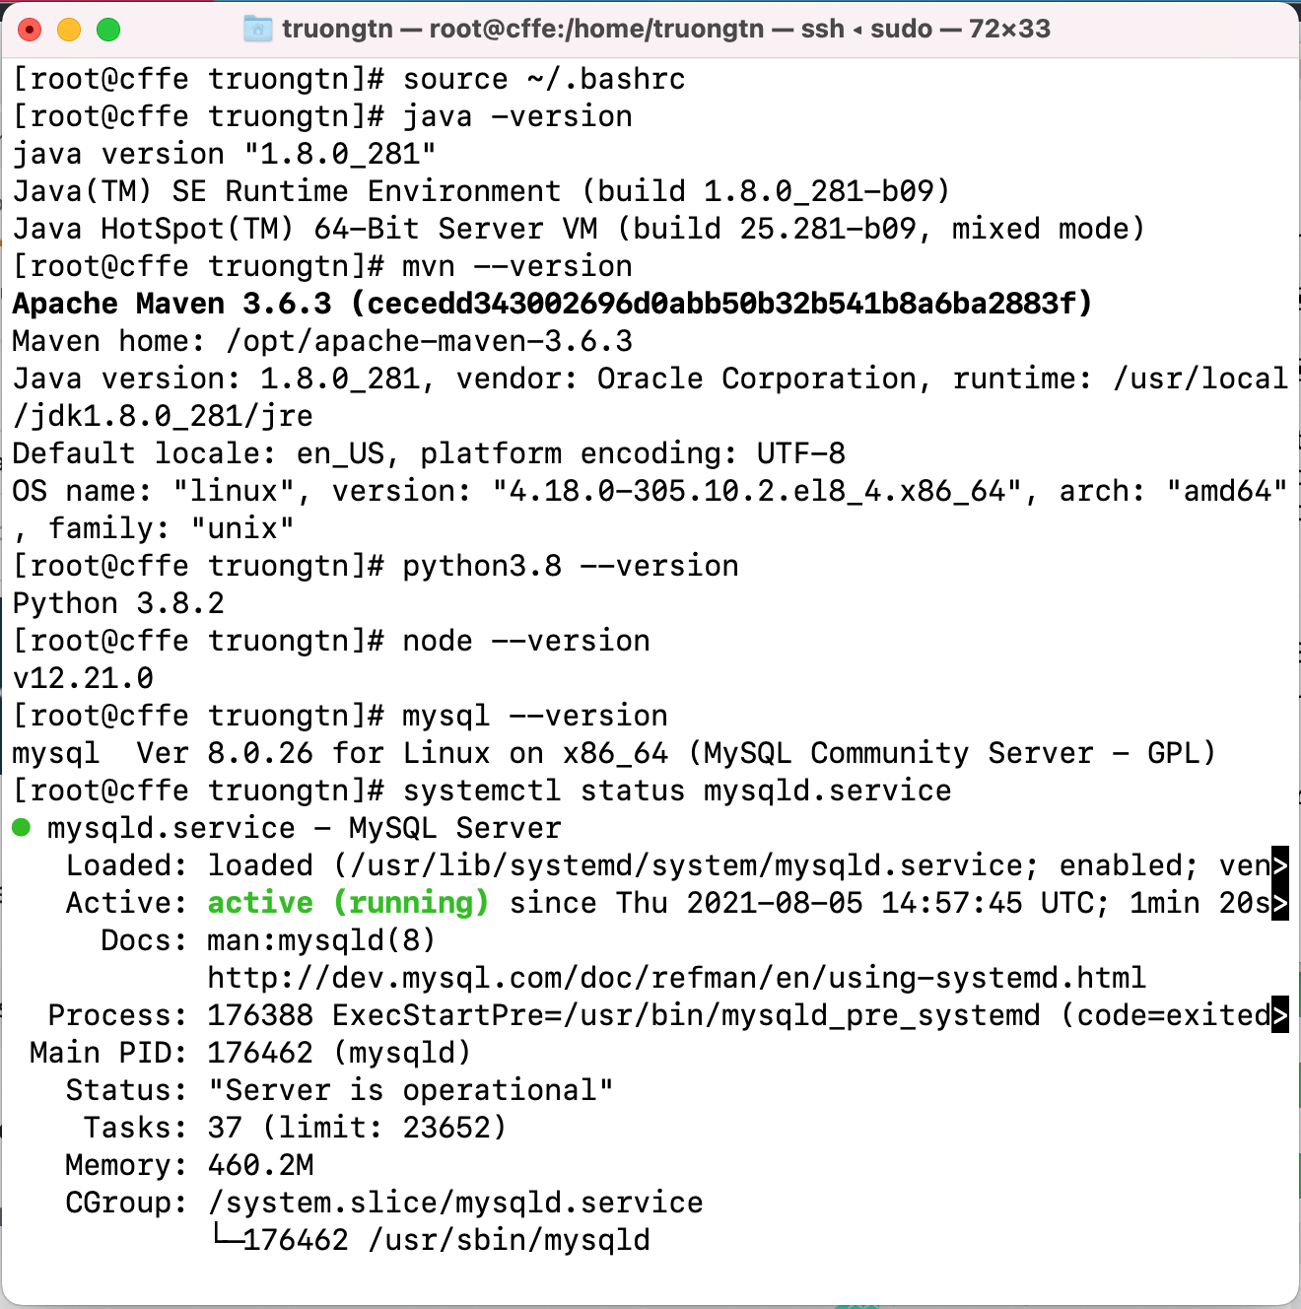

6

5

4

3

2

1

Figure xx. Validate installed module

6. Check “CFFE_SYSTEM.zip” file is downloaded with this command: **ls**

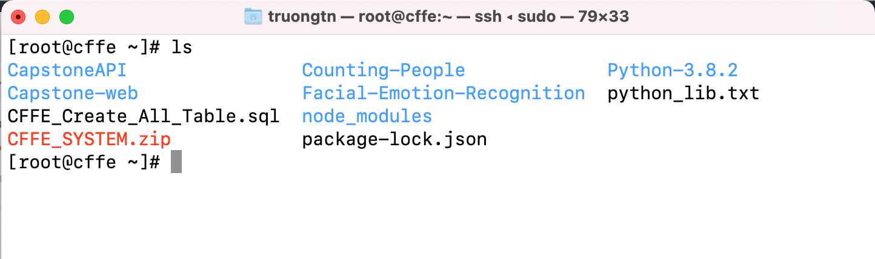

##### 3. Deploy the CFFE application.

1. Create the “CFFE_Database”:

1. Get the temporary password with this command: **grep 'temporary password' /var/log/mysqld.log**

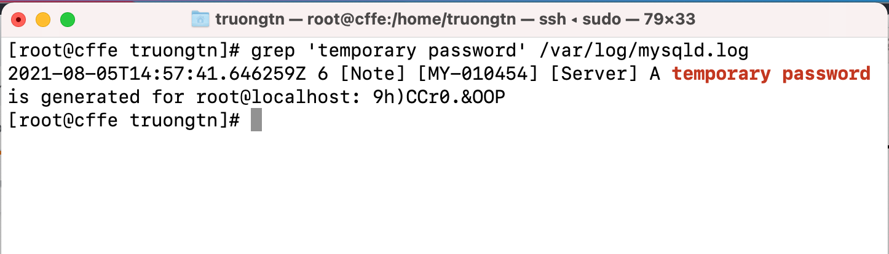

2. Change the password MySQL with this command: **mysql_secure_installation**

1. Input temporary password (1)

2. Input “y” to the change password (2)

3. Input new password and re-type password (3)

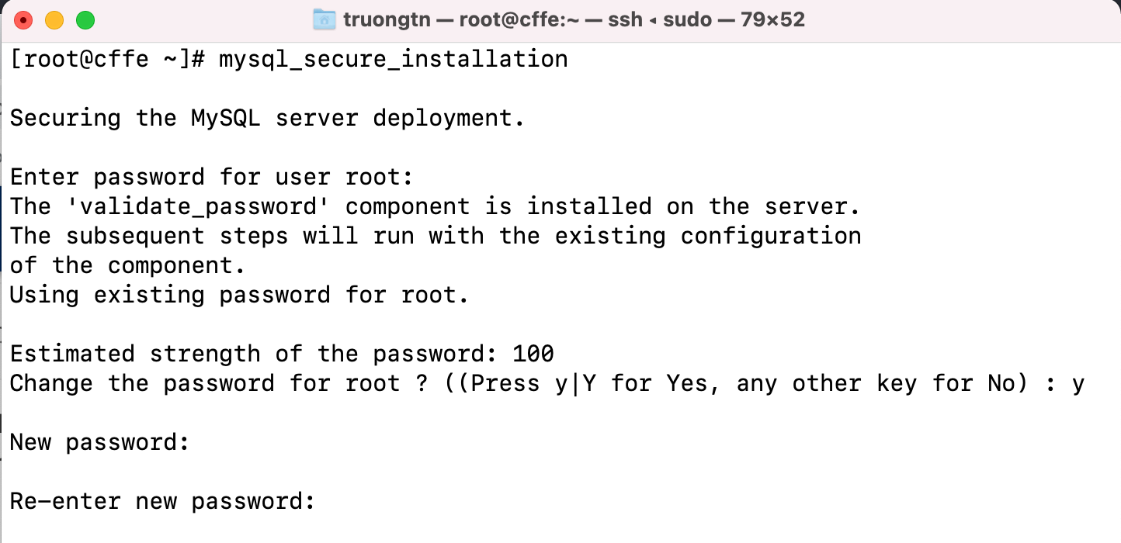

3

2

1

2. Create the “CFFE_Database” by running **mysql -u root -p < CFFE_Create_All_Table.sql** command with the password.



3. Check created “CFFE_Database”: run **mysql -u root -p** command with the password. Then, run **show databases;** command.

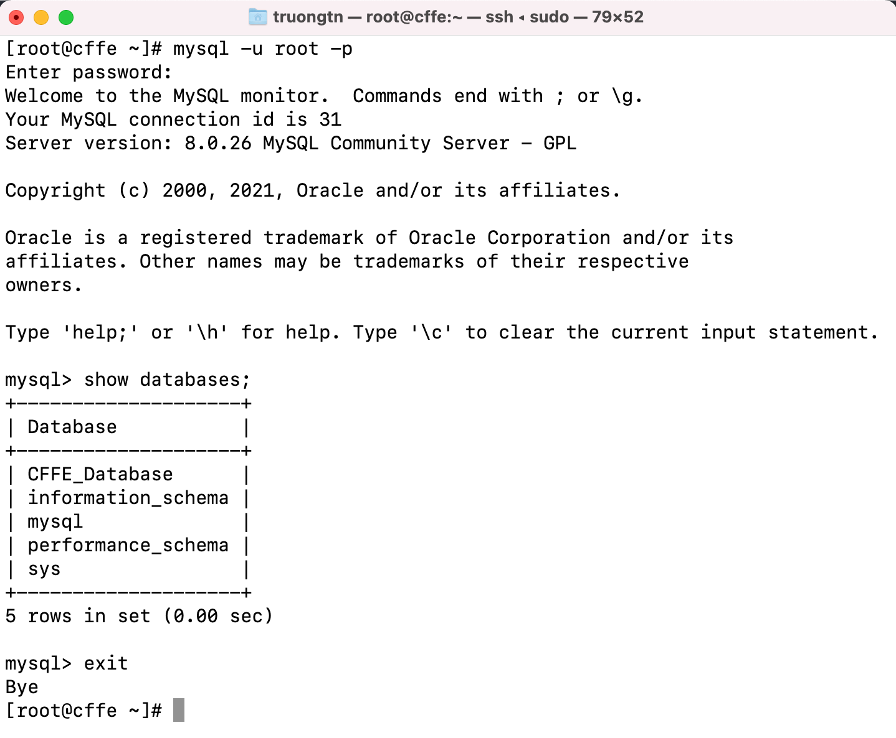

2. Edit config files.

1. Edit password MySQL in the file: **/root/CapstoneAPI/src/main/resources/SqlMapConfig.xml**

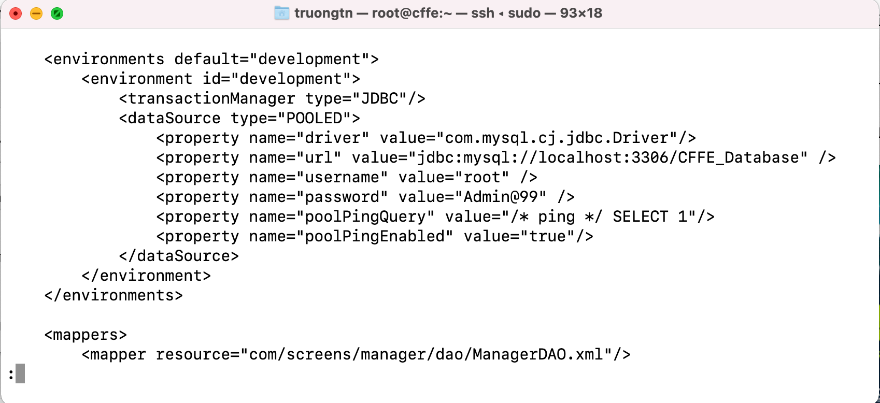

2. Get the public IP address with this command: **curl ifconfig.me**

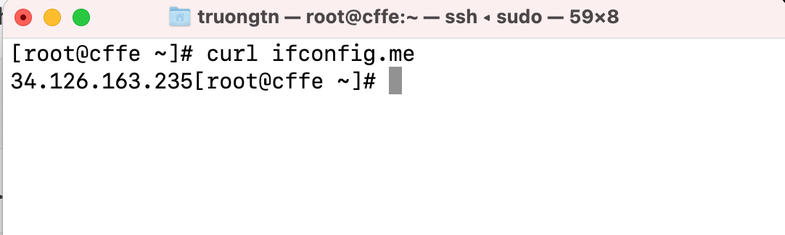

3. Change the public IP address in this file:

**Capstone-web/src/services/api.js**

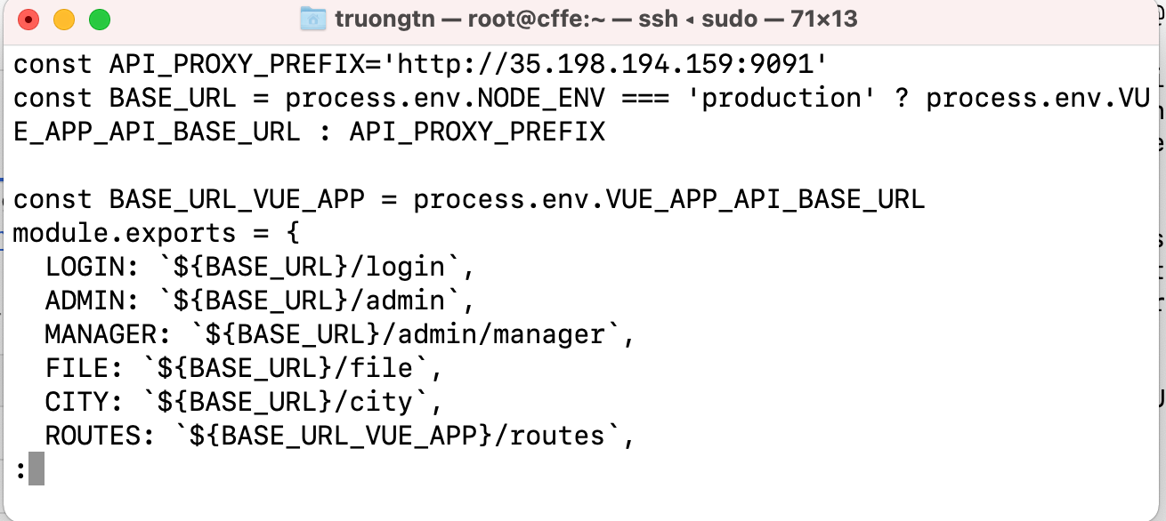

3. Deployment CFFE application.

1. Deploy the application with this command: **source ./DeploymentAPP.sh**



2. Access Backend API: Open browser and input URL:

**[public IP Address]:9091/swagger-ui/index.html**



3. Access CFFE web: Open browser and input URL:

**[public IP Address]:8080**



##### 4. Run Mobile Application

1. Click in Mobile.apkfile:



2. Show popup then click **Install**.



3. Wait for install Mobile app



4. Finish install then click **Open**



5. Show login page in Mobile app

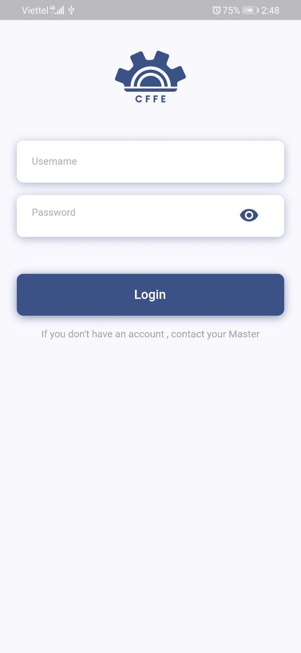

## 3. User Manual

### 3.1 Terms and definitions

N/A

### 3.2 System requirements

*See to* *section2.1*

### 3.3 Application Usage

#### 3.3.3. CFFE-Admin (Mobile)

**a. Overview**

Application used by admin when want to:

+ Login

+ Logout

+ View statistics

+ View video

+ Manage manager

+ Manage store

+ Manage camera

+ Manage product

+ Manage category

+ Manage own profile

Hình của Luận

**b. Login page:**



|  |  |
| --- | --- |
| **Step** | **Description** |
| 1 | Admin inputs the user. |
| 2 | Admin clicks “Login” button. |

**c. Dashboard page:**



|  |  |
| --- | --- |
| **Step** | **Description** |
| 1 | Admin clicks “navigator” icon to view drawer navigator. |
| 2 | Admin clicks “Profile” item to view own profile. |
| 3 | Admin clicks “Logout” item to logout from the application. |

**d. Profile page.**



|  |  |
| --- | --- |
| **Step** | **Description** |
| 1 | Admin clicks the item to change own information. |
| 2 | Admin clicks the item to change own avatar. |
| 3 | Admin clicks the item to change own password. |

1. Update own information.



|  |  |
| --- | --- |
| **Step** | **Description** |
| 1 | Admin clicks “back” icon to cancel the command. |
| 2 | Admin edits the necessary information. |
| 3 | Admin clicks “Save” button to update own information |

2. Change own avatar.

 

|  |  |
| --- | --- |
| **Step** | **Description** |
| 1 | Admin clicks “Back Arrow” icon to cancel the command. |
| 2 | Admin click “camera” icon to choose image from own mobile. |
| 3 | Admin clicks “Save” button to update own avatar. |

3. Change own password

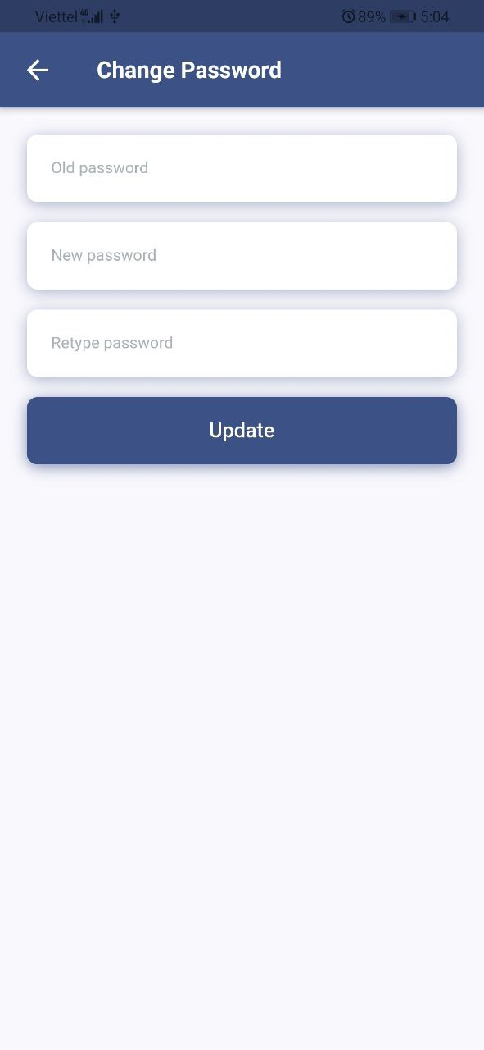

|  |  |
| --- | --- |
| **Step** | **Description** |
| 1 | Admin clicks “back” icon to cancel the command. |
| 2 | Admin edits the necessary information. |
| 3 | Admin clicks “Update” button to update password. |

**e. Video page**



|  |  |
| --- | --- |
| **Step** | **Description** |
| 1 | Admin choose value filter for searching. |
| 2 | Admin clicks “Search” button to search the video. |
| 3 | Admin choose item to view the video detail. |

**f. Manager page**



|  |  |
| --- | --- |
| **Step** | **Description** |
| 1 | Admin inputs a search value and choose status dropdown |
| 2 | Admin clicks a store to view store detail. |
| 3 | Admin clicks “Add” icon to create the manager. |

1. Create the manager



|  |  |
| --- | --- |
| **Step** | **Description** |
| 1 | Admin clicks “Back Arrow” icon to cancel the command. |
| 2 | Admin enters manager information. |
| 3 | Admin clicks “Create” button to create a new manager. |

**g. Manager Detail Page**

 

|  |  |
| --- | --- |
| **Step** | **Description** |
| 1 | Admin clicks the item to update the manager’s information. |
| 2 | Admin clicks the item to change the manager’s avatar. |
| 3 | Admin clicks the item to reset the manager’s password. |
| 4 | Admin clicks the item to delete the manager. |
| 5 | Admin clicks the “Choose Store” button to choose store. |
| 6 | Admin clicks the “Remove Store” button remove store from the manager. |

1. Update the manager information

|  |  |
| --- | --- |
| **Step** | **Description** |
| 1 | Admin edits the necessary information of the manager. |
| 2 | Admin clicks “Cancel” button to cancel the command. |
| 3 | Admin clicks “Update” button to update the manager information. |

1. Change the manager avatar.

 

|  |  |
| --- | --- |
| **Step** | **Description** |
| 1 | Admin clicks “Back Arrow” icon to cancel the command. |
| 2 | Admin click “camera” icon to choose image from own mobile. |
| 3 | Admin clicks “Save” button to update the manager’s avatar. |

2. Delete the manager



|  |  |
| --- | --- |
| **Step** | **Description** |
| 1 | Admin clicks “back arrow” icon to cancel the command. |
| 2 | Admin inputs an inactive reason. |
| 3 | Admin clicks “Save” button to delete the manager. |

3. Reset the manager password.



|  |  |
| --- | --- |
| **Step** | **Description** |
| 1 | Admin clicks “No” button to cancel the command. |
| 2 | Admin clicks “Yes” button to reset the manager password. |

5.Add the store into the manager

|  |  |
| --- | --- |
| **Step** | **Description** |
| 1 | Admin inputs a search value to find by store name. |
| 2 | Admin chooses a store in the available list. |
| 3 | Admin clicks “Cancel” button to cancel the command. |
| 4 | Admin clicks “Ok” button to add the store into the manager. |

6. Remove the store from the manager.

|  |  |
| --- | --- |
| **Step** | **Description** |
| 1 | Admin clicks “Cancel” button to cancel the command. |
| 2 | Admin clicks “Ok” button to remove the store from the manager. |

**e. Store page**

|  |  |
| --- | --- |
| **Step** | **Description** |
| 1 | Admin inputs a search value. |
| 2 | Admin chooses a filter which is all cities or a city in the dropdown list. |
| 3 | Admin chooses a filter which is all statuses, active, pending or inactive. |
| 4 | Admin clicks “New” button to create a new manager. |
| 5 | Admin clicks a username to view manager detail. |
| 6 | Admin clicks a store to view store detail. |

1. Create a new store

|  |  |
| --- | --- |
| **Step** | **Description** |
| 1 | Admin clicks the close button to close the pop up. |
| 2 | Admin enters store information. |
| 3 | Admin clicks “Cancel” button to cancel the command |
| 4 | Admin clicks “Ok” button to create a new store. |

**f. Store detail page**

|  |  |
| --- | --- |
| **Step** | **Description** |
| 1 | Admin clicks the icon to change the store avatar. |
| 2 | Admin clicks “Pending” button to show “Inactive” button. |
| 3 | Admin clicks the button to delete the store |
| 4 | Admin clicks the icon to view the store information. |
| 5 | Admin clicks the icon to update the store information. |
| 6 | Admin clicks the icon to add a manager into the store. |
| 7 | Admin clicks the icon to view product list of the store. |
| 8 | Admin clicks the icon to view camera list of the store. |
| 9 | Admin clicks the icon to remove the manager from the store. |

1. Change the store avatar

|  |  |
| --- | --- |
| **Step** | **Description** |
| 1 | Admin clicks the icon to close the popup. |
| 2 | Admin clicks the button to choose the store avatar from own computer. |
| 3 | Admin clicks “Cancel” button to cancel the command |
| 4 | Admin clicks “Ok” button to change the store avatar. |

2. Delete the store.

|  |  |
| --- | --- |
| **Step** | **Description** |
| 1 | Admin inputs an inactive reason. |
| 2 | Admin clicks “Cancel” button to cancel the command |
| 3 | Admin clicks “Ok” button to delete the store. |

3. Update the store information.

|  |  |
| --- | --- |
| **Step** | **Description** |
| 1 | Admin edits the necessary information of the store. |
| 2 | Admin clicks “Cancel” button to cancel the command. |
| 3 | Admin clicks “Update” button to update the store information. |

4. Add a manager into the store

|  |  |
| --- | --- |
| **Step** | **Description** |
| 1 | Admin inputs a search value to find by username. |
| 2 | Admin chooses a store in the available list. |
| 3 | Admin clicks “Cancel” button to cancel the command. |
| 4 | Admin clicks “Ok” button to authorize the manager from the store. |

5. Remove the manager from the store

|  |  |
| --- | --- |
| **Step** | **Description** |
| 1 | Admin clicks “Cancel” button to cancel the command. |
| 2 | Admin clicks “Ok” button to remove the manager from the store. |

**f. Camera page**

|  |  |
| --- | --- |
| **Step** | **Description** |
| 1 | Admin inputs a search value to find by camera name. |
| 2 | Admin chooses a filter which is all stores or a store name in the dropdown list. |
| 3 | Admin chooses a filter which is all statuses, active, pending or inactive. |
| 4 | Admin clicks “New” button to create a new camera. |
| 5 | Admin clicks a camera name to view camera detail. |
| 6 | Admin clicks a store name to view store detail. |

2. Create a new camera

|  |  |
| --- | --- |
| **Step** | **Description** |
| 1 | Admin clicks the close button to close the pop up. |
| 2 | Admin enters camera information. |
| 3 | Admin clicks “Cancel” button to cancel the command |
| 4 | Admin clicks “Ok” button to create a new camera. |

**g. Camera detail**

|  |  |
| --- | --- |
| **Step** | **Description** |
| 1 | Admin clicks the icon to change the camera avatar. |
| 2 | Admin clicks “Pending” button to show “Inactive” button. |
| 3 | Admin clicks the button to delete the camera. |
| 4 | Admin clicks the icon to update the camera information. |

1. Change the camera avatar.

|  |  |
| --- | --- |
| **Step** | **Description** |
| 1 | Admin clicks the icon to close the popup. |
| 2 | Admin clicks the button to choose the camera avatar from own computer. |
| 3 | Admin clicks “Cancel” button to cancel the command |
| 4 | Admin clicks “Ok” button to change the camera avatar. |

2. Delete the camera

|  |  |
| --- | --- |
| **Step** | **Description** |
| 1 | Admin inputs an inactive reason. |
| 2 | Admin clicks “Cancel” button to cancel the command |
| 3 | Admin clicks “Ok” button to delete the camera. |

3. Update the camera information

|  |  |
| --- | --- |
| **Step** | **Description** |
| 1 | Admin edits the necessary information of the camera. |
| 2 | Admin clicks “Cancel” button to cancel the command. |
| 3 | Admin clicks “Update” button to update the camera information. |

**h. Product page**

|  |  |
| --- | --- |
| **Step** | **Description** |
| 1 | Admin inputs a search value to find by product name. |
| 2 | Admin chooses a filter which is all categories or a category in the dropdown list. |
| 3 | Admin chooses a filter which is all statuses, active or inactive. |
| 4 | Admin clicks “New” button to create a new product. |
| 5 | Admin clicks a camera name to view camera detail. |

1. Create a new product

|  |  |
| --- | --- |
| **Step** | **Description** |
| 1 | Admin clicks the close button to close the pop up. |
| 2 | Admin enters product information. |
| 3 | Admin clicks “Cancel” button to cancel the command |
| 4 | Admin clicks “Ok” button to create a new product. |

**i. Product detail page**

|  |  |
| --- | --- |
| **Step** | **Description** |
| 1 | Admin clicks the icon to change the product avatar. |
| 2 | Admin clicks “Active” button to show “Inactive” button. |
| 3 | Admin clicks the button to delete the product. |
| 4 | Admin clicks the icon to update the product information. |

1. Change the product avatar.

|  |  |
| --- | --- |
| **Step** | **Description** |
| 1 | Admin clicks the icon to close the popup. |
| 2 | Admin clicks the button to choose the product avatar from own computer. |
| 3 | Admin clicks “Cancel” button to cancel the command |
| 4 | Admin clicks “Ok” button to change the product avatar. |

2. Delete the product

|  |  |
| --- | --- |
| **Step** | **Description** |
| 1 | Admin inputs an inactive reason. |
| 2 | Admin clicks “Cancel” button to cancel the command |
| 3 | Admin clicks “Ok” button to delete the product. |